**The Effects the Existence of Financial Openness, Monetary Independence, and**

**Exchange Rate Stability Have on One Another in Consideration of the Impossible Trinity**

Nathaniel Sutherland, Ian Saunders, Wesley Berry

Professor Priya Mukherjee

ECON 308: Econometrics

11 December 2016

**Introduction**

The Trilemma, or Impossible Trinity, states that macroeconomic policy makers must choose only two of three policy choices: monetary independence, a fixed exchange rate, and financial openness. The Bretton-Woods system (1944-71) pegged foreign exchange rates to the dollar, which was in turn pegged to a gold standard. Over time, this led to the overvaluing of US currency, meaning American goods and services were relatively more expensive than were those of other states - which limited their potential for growth. Countries began to seek to redeem their currencies for gold (or seek monetary independence), which ultimately led to the US leaving Bretton Woods system. This demonstrated that a fixed exchange rate, financial openness, and monetary independence could not simultaneously be present, since the system broke down once countries sought new exchange rates (revaluing their currencies). A similar situation can be seen in the European Union, where there is a fixed exchange rate and financial openness, but no monetary independence - because it is centralized by the European Central Bank. In short, the Trilemma has important implications for interstate economic frameworks, and their long-term success or failure. Such economic systems are increasingly important for the globalized economy, so analyzing the approaches states have toward the three policies has important implications for how states integrate into the rapidly globalizing economy.

**Data**

Each of the independent variables are measured using separate indices pertaining the 150 countries examined. Each index produces results ranging from 0 to 1, and no data on the United States was included for any of the three variables.

The first variable that is looked at is the Exchange Rate Stability Index. This is calculated by normalizing the annual standard deviations of the monthly exchange rate between the home country and base country from 0 to 1. Higher values of this index indicates a more stable movement of the base country against a chosen home country.

The next data examined are the calculations for each Monetary Independence Index. Production of this index entails taking the reciprocal of the annual correlation between the monthly interest rates of the home country and base country. Reciprocating the variable means that as the values of this index rise, the monetary independence of the corresponding country will also rise.

The final variable examined is the Financial Openness Index, which uses the Index of Capital Accounts Openness (KAOPEN) first formulated by Chinn and Ito (2006, 2008). Their calculation was based on data from the International Monetary Fund’s *Annual Report on Exchange Arrangements and Exchange Restrictions*. Information the was used in the index included indications of the presence of multiple exchange rates, restrictions on current account transactions, capital account transactions, and requirements of the surrender of export proceeds. Most of this information relies on the reported information of countries, allowing us to examine the policy intentions of each country instead of using specifically defined data to determine their intentions.

**Regression**

Three different regression models were run to gather results. Each of the models regresses one of either Monetary Independence, Financial Openness, or Exchange Rate Stability as a dependent variable, while the other two become the independent variables. These regressions make the most sense, as they will show how the different policies affect each other. This method can potentially show which policies tend to pair together the most. The regressions will also demonstrate how the two independents variables will jointly affect the independent variable. The overall simplicity of the model will make the tests easy to run, and the results easy to interpret.

**Monetary Independence and Financial Openness on Exchange Rate Stability**

The regression equation used here is:

*ERSi = β0 + β1MIi + β2FOi + µi*

This model shows the effects of Financial Openness and Monetary Independence on the Exchange Rate Stability. The results of the regression are shown below.

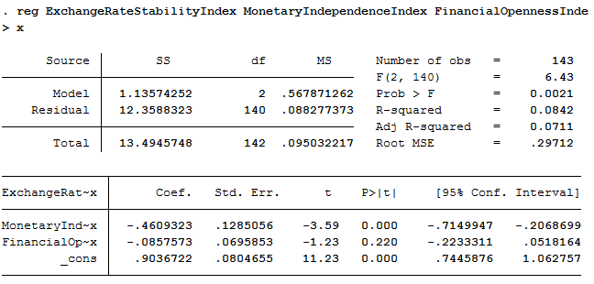

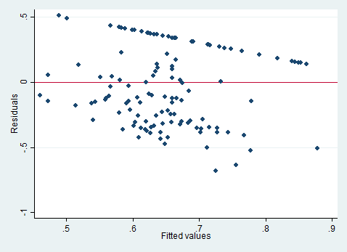

The effect of Financial Openness (FO) on Exchange Rate Stability (ERS) is statistically insignificant at a 5% significance level, as indicated by the p-value (.220) derived from the t-test. Monetary Independence (MI) does have a significant effect, with a coefficient of -.4609323. MI is negatively correlated with ERS. The F-test demonstrates that the model is statistically significant. The coefficient of determination (adjusted R-squared) is .0711, meaning the model predicts 7% of the variance in ERS.

From the residual versus fitted (RVF) values plot shown above, there is a moderate degree of heteroskedasticity. The residuals clearly curve downwards, especially at the top of graph where the values are linear. This indicates that Gauss-Markov assumption three has been violated, and that the model is not well fitted.

**Financial Openness and Exchange Rate Stability on Monetary Independence**

The regression equation used here is:

*MIi = β0 + β1FOi + β2ERSi + µi*

This model shows the effect of Financial Openness and Exchange Rate Stability on Monetary Independence. The results of the regression are shown below.

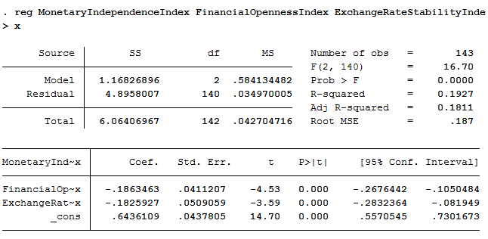

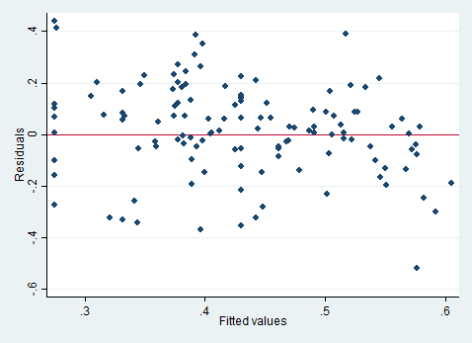

Both FO and ERS have highly significant effects on MI. These effects are very similar: -.1863463 for FO and -.1825927 for ERS. This model clearly demonstrates that FO and ERS are negatively correlated with MI. The adjusted R-squared value of .1811 is higher than the other two models as well: more of the variance of MI can be predicted by FO and ERS than by any other combination. Furthermore, the RVF plot of the residuals illustrates that the model is well-fitted. There is an overall random distribution (aside from the left side of the graph), meaning there is little heteroskedasticity. The F-test is also satisfied.

**Exchange Rate Stability and Monetary Independence on Financial Openness**

The regression equation used here is:

*FOi = β0 + β1ERSi + β2MIi + µi*

This model shows the effect of Exchange Rate Stability and Monetary Independence on Financial Openness. The results from the graph are shown below.

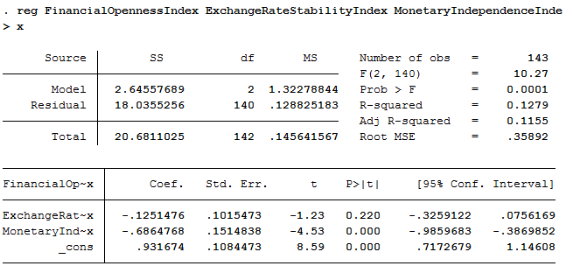

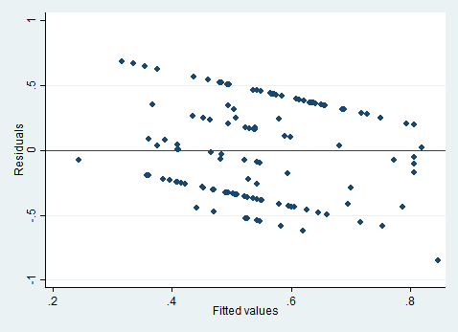

The effect of ERS on FO is insignificant: the p-value of .220 is greater than .05. MI has a strongly negative correlation with FO, with a coefficient of -.6864768. The model predicts 11.5% of the variance in FO. Overall, the model is significant since it passes the F-test. However, it is highly heteroskedastic. The RVF plot of the residuals clearly demonstrates that the model is not well-fitted, as was the case with the first regression.

**Regression Analysis**

Each statistically significant correlation between the three variables was negative, implying that the trilemma holds true: the presence of two variables reduces the likelihood of the presence of the third. Exchange Rate Stability and Financial Openness have no effect on each other. Both have about the same effect of -.18 on Monetary Independence. Monetary Independence has strong effects on both Financial Openness and Exchange Rate Stability, -.68 and -.46, respectively. From the three regressions, it is demonstrated that MI is key in affecting (and being affected by) the other two.

The only robust regression was that of FO and ERS on MI. Furthermore, this regression has a much higher R-squared value of .1811, validating of the effects of FO and ERS on MI. Yet, the partial effects of FO and ERS on MI was much lower than the effect MI had on them. Perhaps this implies that the FO-ERS combination allows for a more balanced economic system than would any other combination, since any combination with MI reduces the likelihood that either FO or ERS will be present. With the FO-ERS combination, there might at least be a degree of MI. While these regressions do not indicate preferences of countries for a certain MI-FO-ERS combination, they do indicate the tendency of states to choose the FO-ERS combination in creating economic systems.

**Conclusion**

MI should be considered more than either FO or ERS in analyzing various combinations of the trilemma. FO and ERS are not statistically significant in their effects on each other, which is reflective of modern economic systems which tend to sacrifice MI for the sake of FO and ERS. The European Union and the Bretton Woods System are examples of this. The implication of the data obtained from the regression also points to the fact that FO-ERS economic systems tend to break down when MI is pursued by a country, since MI has strongly negative correlations with both FO and ERS. This was the case in the Bretton Woods System as states sought to revalue their currencies through monetary policy. It is also the case now in Europe, as the isolationism has gained traction through state political systems. This is evidenced in the politics of Spain, Germany, France, and especially in the U.K.’s vote to leave the EU. The data supports historical precedent, which demonstrates that increased support for MI leads to a breakdown of economic systems. This was the case with the Bretton Woods System, and will likely be the case with the European Union. Since the state is the entity behind a desire for monetary independence, recreating its role in trade agreements might better prevent systemic breakdown. Recognizing this phenomenon is crucial to understand how new systems may be formed, and what combination of Monetary Independence, Financial Openness, and Exchange Rate Stability might be present.

**Limitations and Recommendations**

In an attempt to reduce limitations in our model testing, our regression utilized data pertaining specifically to each of the three trilemma variables, although certain restraints were found. The first hindrance to our regression was the lack of information available for each possible country that could be examined. Of the 193 countries that are members of the United Nations, only 150 countries had obtainable data for each of the variables. The model would definitely be improved with more data on the forty-three countries not included in the regression, as increasing the pool of information from which our results are inferred would only strengthen the interpretations. It would also be beneficial to have updated information, as the most recent data available comes from 2013. The lack of information on the United States opens the possibility of further testing for the effect of American monetary policy on the rest of the financial world. Another supplementary model testing could examine the information as a time series regression, looking at changes in the selected indexes on an annual basis.

**Works Cited**

Notes on the Trilemma Measures - Portland State University. (n.d.). Retrieved October 24, 2016, from http://web.pdx.edu/~ito/ReadMe_trilemma_indexes.pdf&p=DevEx,5085.1

The Trilemma Indexes.. Retrieved October 24, 2016, from http://web.pdx.edu/~ito/trilemma_indexes.htm